Project Time Tracker

# Project Definition:

The Project Time Tracker is a Blazor Web Assembly based system designed to record and track time against projects within a company recording the time each company member spends.

# Aims:

The aim of this project is to improve upon the existing software solution that tracks projects and the time spent against them by adding and Improve the functionality of the system. This will be achieved by by adding reporting and other ease of life improvements.

# Objectives:

The objective of the project is to produce a fully functioning system by the 12th of April

# Scope:

Over the course of this project, I will add the following features:

The system will allow have a set of default application types that set the project tasks on creation.

The system will allow and store a historic backlog of comments on a daily granularity.

The system will give the setup users the ability to perform a closeout report for each project.

The system will be able to report on the Hours entered by each member of staff.

The system will be able to generate a report to summarise time spent on projects over the last month.

The system will be able to report on the project closeouts.

# Technologies:

The Solution will be based on the Blazor Web Assembly Framework for front end development C# Asp.Net Framework for the server-side code and Entity framework core for database manipulation.

# Projects Screen

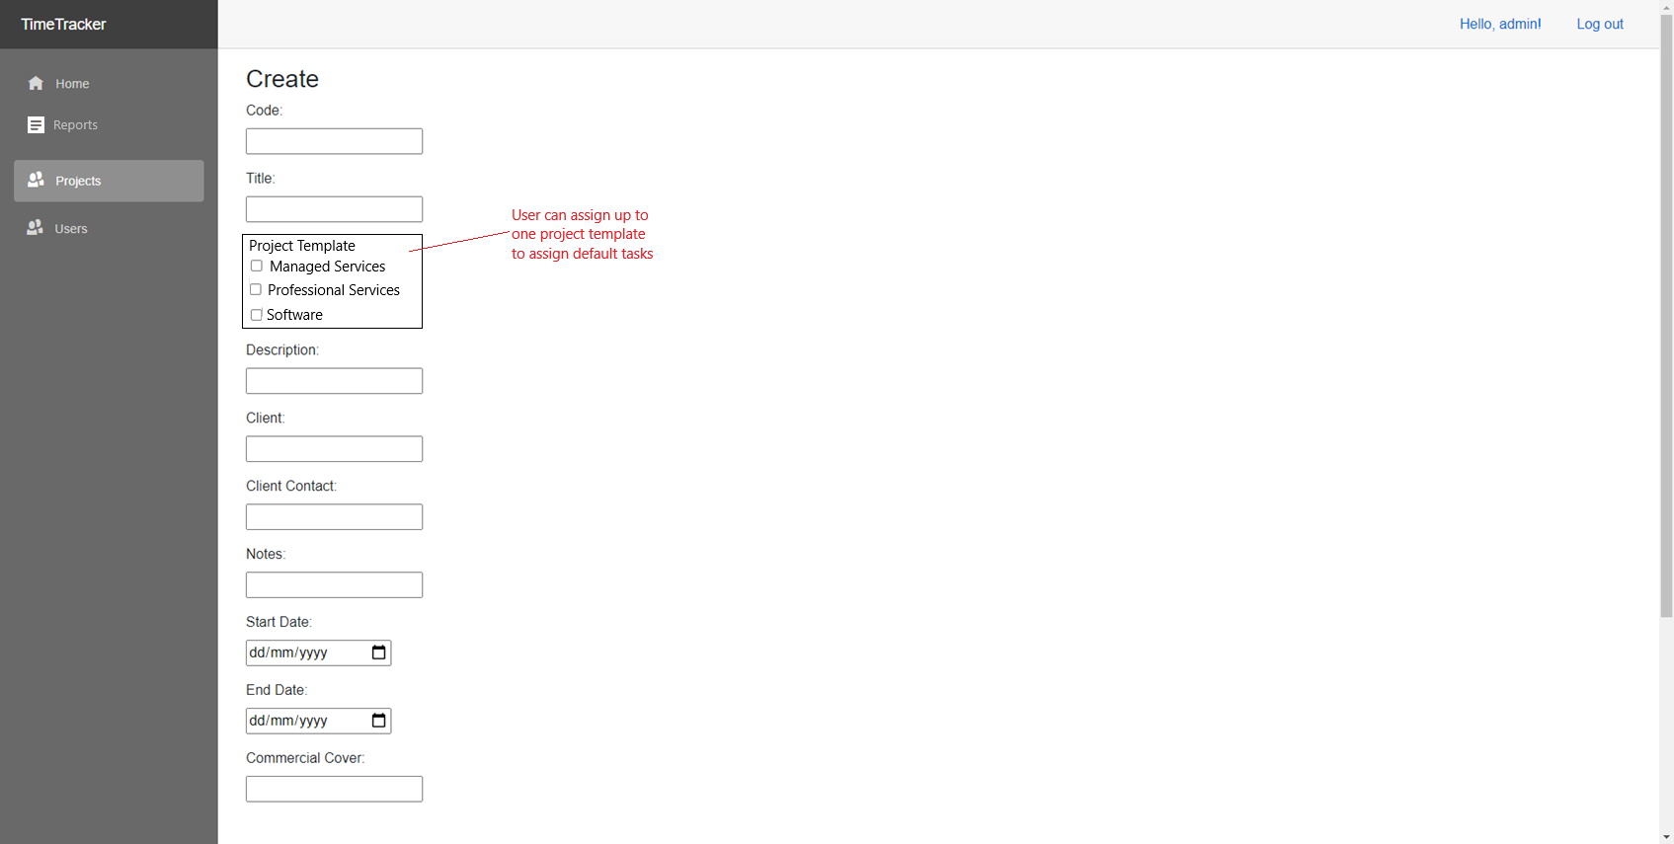

# Project Dashboard

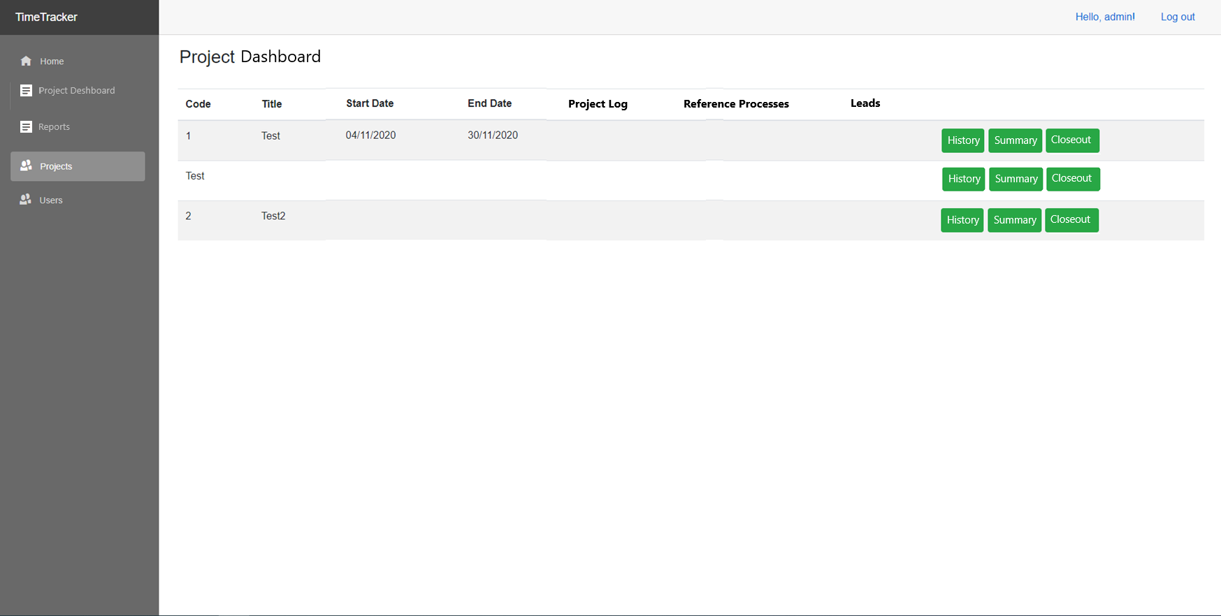

# Project Closeout Screen

